Understanding the User

2.7: Mobile-First Design

Learning Goals

Discuss key components of mobile-first design and how to apply them

 Estimated Read Time: 30 Minutes.

Introduction

Hey there! Now that you’ve finished some informative user flows for your project, it’s time for a change of pace. In this Exercise, we’ll be discussing an important concept that’s been trending for the past few years within the UX space—mobile-first design.

With mobile devices becoming more and more pervasive in the global community ([StatCounter](http://gs.statcounter.com/platform-market-share/desktop-mobile-tablet/worldwide" \t "_blank) listed mobile web use at 50.31% in 2016—higher than desktop traffic at 44.79%), the web is quickly becoming an experience we carry in our pockets. This is a global trend that will continue to see growth as time goes on, and UX designers have turned to a paradigm known as mobile-first design to ensure their products align with global expectations.

In this Exercise, we’ll discuss why the UX industry has moved in this direction, going over the benefits as well as the reasoning. Afterwards, we’ll talk about how to apply mobile-first design principles to your own projects. Let’s get started!

What Is Mobile-First Design?

Mobile-first design is essentially what it sounds like—product teams creating content and design for the mobile version of websites before considering the content and design for tablet or desktop versions. **Content** is a fairly all-encompassing term, but within the context of mobile design, it generally includes all of the imagery, functionality, and written text on a website.

"This means you’re talking about the structure of the content, the size and shape of it, what it will do, the expected audiences, how often the content will be updated and how much content there will be. Designers can then take this information and begin building designs around these early expectations even if the content is not ready."  
[ADOBE: BEST PRACTICES FOR CONTENT PLANNING IN UX DESIGN](https://blogs.adobe.com/creativecloud/best-practices-for-content-planning-in-ux-design/)

Here are a few examples of content in this context:

* Onboarding text
* Social sharing links
* Images
* Videos

If you know the types of content you will need early on, you can better design an app that's optimized for those demands.



Before we go any further it’s important to note that the concept of mobile-first design only applies when designing responsive web applications or websites. **Mobile-first design** is used alongside responsive web design: a technical approach that enables web pages to re-organize their content based on the type and size of device they are being viewed on.

Responsive Web App or Native App?

Responsive websites are not native to any kind of device and run in a web browser, such as Chrome or Firefox. Native apps, on the other hand, are designed to work with one specific operating system, such as iOS or Android, and are downloaded directly to a device that uses a particular operating system. For example, apps from the Google Play store can only be downloaded to devices using the Android operating system.

Now that you're aware of the differences between responsive web apps and native apps, let's dig deeper into the principles of mobile-first design. And since your course project will focus on a responsive web app, you should also start thinking about how mobile-first design can be applied to your project.

Why Mobile First?

Google was one of the first organizations to recognize the benefits of mobile-first design and also one of the first to publicly adopt this strategy. In 2010, Eric Schmidt (the CEO of Google at the time) gave a keynote speech at Mobile World Congress, saying:

"We understand that the new rule is mobile first. Mobile first in everything. Mobile first in terms of applications. Mobile first in terms of the way people use things. And it means … that we have a role now to inform, to educate through all these devices."

You can read more about this announcement here: [Google's New Rule: Mobile First](http://www.pcmag.com/article2/0,2817,2359752,00.asp).

What was it that Google understood that other companies at the time didn’t? Aside from the obvious traffic statistics we talked about in the introduction, mobile-first design is viewed by UX professionals as a way for designers to focus their attention on what really matters when building a website. Let’s take a look at some of the benefits of designing in this way, and then we’ll discuss how you can make a case for this strategy in your own organization.

* **Mobile-first design forces designers to think about users.** As opposed to the old paradigm where designers would work first on a large desktop-sized canvas, now they must consider the much smaller real estate afforded by a mobile device. This means that designers have to understand their users and concentrate on only providing content those users absolutely need while removing secondary content that might be of less importance. The result is a streamlined, lean experience on a mobile device.
* **While the mobile design is first, larger device designs benefit, as well.** The thought here is that with a streamlined and user-centered mobile design, moving up in scale to tablet and desktop designs becomes easier as all the hard work has already been done on mobile. While this is true in many cases, a mobile-first designer should still take the time to appreciate and modify their design for larger resolutions to give users the best experience on any given device.
* **Mobile-first design allows us as designers to offer a faster experience to users.**Since the mobile experiences of these sites are lean, they often don’t have a large amount of imagery and other media assets that need to be loaded, resulting in quick download speeds on the devices that need them the most. Scaling upwards to larger devices offers more media and larger downloads, but larger devices are generally on faster networks that can handle those file sizes.
* **Technology used to develop websites has improved.** Today’s CSS3 and HTML5 are a big improvement over previous technology, and these two descriptive languages working together is what gives us as designers the technical possibility of creating responsive websites in the first place. As a UX designer, you don’t need to be able to write code, but you should have a working understanding of web technology to be proficient at your job and to understand the limitations and possibilities of working on the web.

All in all, it’s a pretty convincing set of benefits that should be heavily considered by any designer. Now, let’s look at the business case for this strategy before diving into how you can apply it to your work.



The [Newsweek](http://www.newsweek.com/) website is a good example of mobile-first in use

Making a Case for a Mobile-First Strategy

As with some of the research methods we discussed earlier in this Achievement, you may at some point in your career find yourself having to advocate for mobile-first design as a solid digital strategy for your organization or client. Let’s discuss some of the ways you can make a case for this strategy:

* **Mobile-first design is a good investment in the future.** Designing in this way ensures that your organization will be headed in the same direction that web usage trends are headed, and this will help to future-proof your product, resulting in fewer costly product updates as usage of the web evolves.
* **It’s a more user-centered approach.** As we touched on above, mobile-first design forces you to think about the user and the content in a more focused way. Studies have shown that this focused, user-centered approach leads to better conversion rates and engagement metrics for sites all over the web due to fewer reworks and errors during development. Read [Benefits of User-Centered Design](https://www.usability.gov/what-and-why/benefits-of-ucd.html) for details.
* **It opens up new doors in functionality.** Technologies like touch, haptic feedback, GPS, and more are all currently available on mobile platforms, and they’re slowly moving into the realm of tablet and desktop design, as well. With a mobile-first strategy, these technologies can be considered at the beginning of a project, and innovative thinking when moving into tablet and desktop breakpoints (defined resolution sizes that cause layouts to shift for users) becomes more possible for your design team.
* **Minimal design and minimal code.** By its nature, mobile-first design is minimal and clean. Rather than beginning the process with a larger desktop design coupled with countless features and content blocks, mobile-first starts with just what’s needed on mobile devices and adds only what’s absolutely required on larger devices. It’s a more efficient process that results in a cleaner, more manageable website. For a real-world case study, check out [Building a Better Responsive Website](https://www.smashingmagazine.com/2013/03/building-a-better-responsive-website/) at Smashing Magazine.

Refer to points like these when making the case for your mobile-first design. Remember that you have data on your side! Now, let’s take a look at how you can implement mobile-first design in your project.

Applying Mobile-First Design to Your Own Projects

There are many reasons for implementing this strategy for your own project, but you may be wondering exactly how it’s done. Throughout your user research and analysis, you’ve no doubt reached a core list of functionality and content essential to your users. This is the key concept behind user-centered design, and it’s what we’ve been trying to emphasize throughout this Achievement.

Now, if you were to assume that your project is a responsive website, your next goal would be to take a look at your feature list and prioritize it based on only what’s absolutely necessary for a mobile audience. Keep in mind that mobile is called “mobile” for a reason—these users are often on the go!

TIP!  
It’s also useful at this point to brainstorm what mobile features might enhance the user experience. In the case of our demo app, for example, a responsive website may feature GPS location services on mobile devices so that the site knows where users are in the world and can serve them the appropriate travel guides without the need for searching.

After prioritizing your list, you would then continue into information architecture and wireframing with a minimal set of features based on the mobile breakpoint. With a solid set of mobile wireframes and a mobile strategy, a process called progressive enhancement can be employed.

**Progressive enhancement** is a simple process in which UX designers begin with a mobile design and add only what’s absolutely necessary as they move upward in device resolution. For example, the mobile version of a site may have three content callouts for its primary persona on the homepage. Moving up to the tablet resolution, the designer may add a fourth callout for one of the secondary personas. On the desktop resolution, where a designer has even more room to work with, a fifth callout for the final persona may be added along with social feeds—something of interest to all personas.

During each step of the process (and for each larger display), the designer carefully considers and only adds what’s absolutely necessary. Keeping the site minimal and easy to use should always be a priority, along with serving only the content your personas need to see.

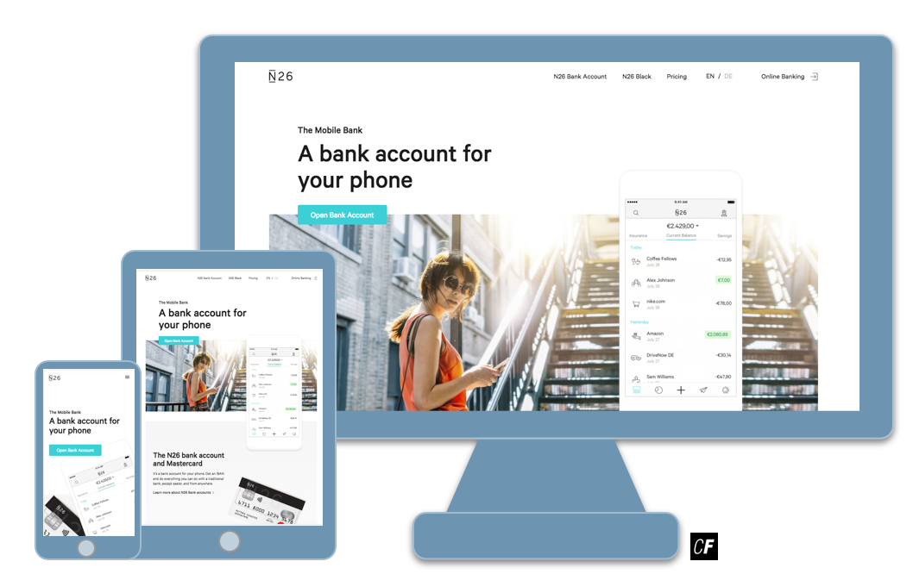

Progressive enhancement of the [N26 website](https://next.n26.com/en-de/) from mobile to tablet and desktop

Mobile-first design is a popular strategy in the UX community right now and rightly so. In order to make the most of your mobile-first designs, here are some additional guidelines to consider when working on your own mobile-first projects:

* Though it’s oftentimes easy to forget, mobile sites are used by our fingers! Wireframes and designs for mobile devices need to have **touch targets (also called hit spaces) that are large enough for our fingers to use**. In their [iOS Human Interface Guidelines](https://developer.apple.com/ios/human-interface-guidelines/ui-controls/buttons/), Apple recommends hit spaces be at least 44pt by 44pt. In addition, text links need adequate margins (the spaces around them) to ensure users won’t accidentally click on something else.
* Many interactive websites count on hover effects for tooltips, product previews, and more. This hover technique, however, isn’t possible on mobile devices! Your site needs a way for mobile users to enjoy these pieces of functionality in a different fashion (**tap and hold interactions** are a common choice).
* People have been using mobile apps long enough that they know how they work. By building experiences that mimic or draw from already existing app functionality, users will intuitively know how to navigate your design. Such experiences include **opportunities to reveal and hide content on demand**. For example, mobile sites often use a “hamburger menu” style navigation, hiding it when a user doesn’t need it but making it readily available on demand with a simple tap.
* Mobile devices tend to use slower connections than desktop or tablet counterparts; therefore, care should be taken when including large graphics or videos in a mobile site design. **Users should be able to load a site within a few seconds.** Save the weighty downloads for larger breakpoints!
* Finally, it’s important that you **test your design on actual devices during the site creation process**. When wireframing your design, for example, export an image and check it out on your personal mobile device from time to time. These tests are simple and often reveal that some parts of your design may be too small to read or simply don’t work on a mobile device.
* **Mobile-first doesn’t mean mobile only!** While the beginning stages of your design should focus on the mobile platform, progressive enhancement for the other devices you support has to be a part of your process. Simply porting the mobile design and features to the tablet and desktop resolution will hurt usability for your site. More about this interesting topic can be read here: [Mobile First Is NOT Mobile Only](https://www.nngroup.com/articles/mobile-first-not-mobile-only/).

Summary

In this Exercise, we discussed mobile-first design in detail. We began by defining mobile-first design and looked at why it’s being used in the industry today. Then, we talked about how to make a business case for mobile-first design before discussing ways of implementing the strategy in your own projects.

In our next and final Exercise of this Achievement, we’ll be talking about another important step for information architecture preparation—the content audit. For now, however, let’s work on a task designed around using the mobile-first strategy for your course project!

Resources

* [A Hands-On Guide to Mobile-First Responsive Design](https://www.uxpin.com/studio/blog/a-hands-on-guide-to-mobile-first-design/)
* [Mobile First Helps With Big Issues](http://www.lukew.com/ff/entry.asp?1117)
* [Mobile-First: A Future-Friendly Approach to UX Design](http://blog.invisionapp.com/mobile-first-a-future-friendly-approach-to-ux-design/)

Take the quiz to test your knowledge on this Exercise.

Take Quiz

Task

* [DIRECTIONS](https://careerfoundry.com/en/course/become-a-ux-designer/exercise/mobile-first-design#directions)
* [SUBMISSION HISTORY](https://careerfoundry.com/en/course/become-a-ux-designer/exercise/mobile-first-design#step_submission_history)

 Estimated Task Time: 2 Hours.

Review what we discussed in this Exercise and create a mobile-first design plan for your project using content relevant to your personas and following a progressive enhancement methodology. In this Task, assume your project is a responsive website (even though it might actually be an app—you may need to use your imagination!). Focus on the placement, flow, and structure of content (i.e, images, text, videos, documents, etc).

If you need a good starting point, take a look at this [sample design plan](https://s3.amazonaws.com/coach-courses-us/public/courses/ux-immersion/A2/E6/A2E6_sampledesignplan.png) for our demo project, but remember—this is in no way an “answer key!”

**Directions**

1. Create a spreadsheet or similar document and split it into 3 sections: “Mobile Content,” “Tablet Content,” and “Desktop Content.”
2. Starting with the “Mobile Content” section, record a list of content based on your user personas’ needs. Include a notes column where you can write down your justification for each piece of included content.
3. Repeat this process for the “Tablet Content” and “Desktop Content” sections using a progressive enhancement process as outlined in the Exercise.
4. Save your content document as a PDF file and upload it here. Feel free to share additional thoughts or ask questions in the submission box.